Social Story: Greeting Someone at School

The reason I decided to write a social story on how to greet people is because greetings is a large skill we are working on in the classroom that I am working in. I made this social story for one student in mind. The client I had in mind is a 6-year-old girl. Greeting is one of the priority skills we are currently working on with her. When someone says hi to her she will usually look but you have to say hi 2-3 times before she responds. When she is prompted to say hi first she usually will not.

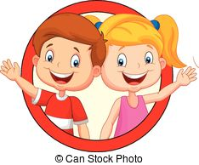

Greeting Someone at School

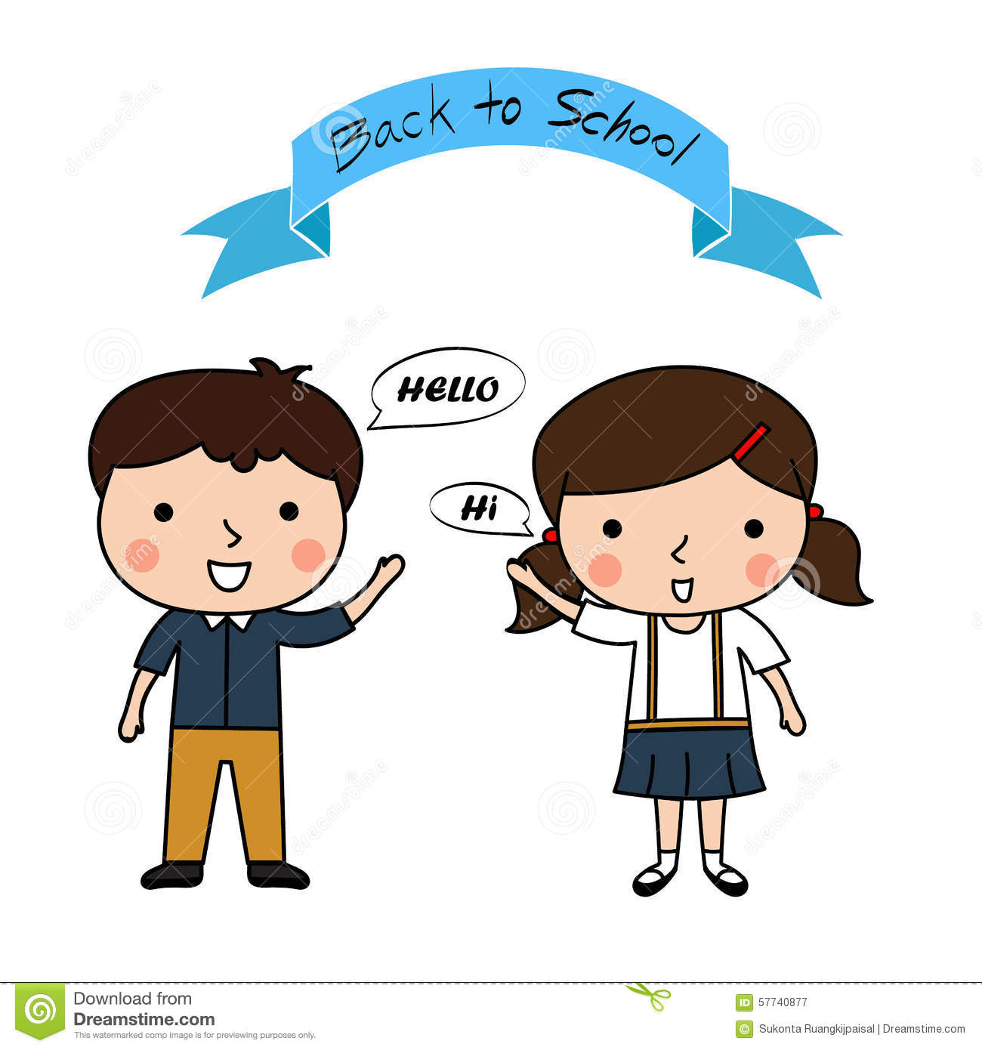

When I am at school I see a lot of people that I know. I will try to smile, look at them and say “hi” or “hello”. I might wave to them too.

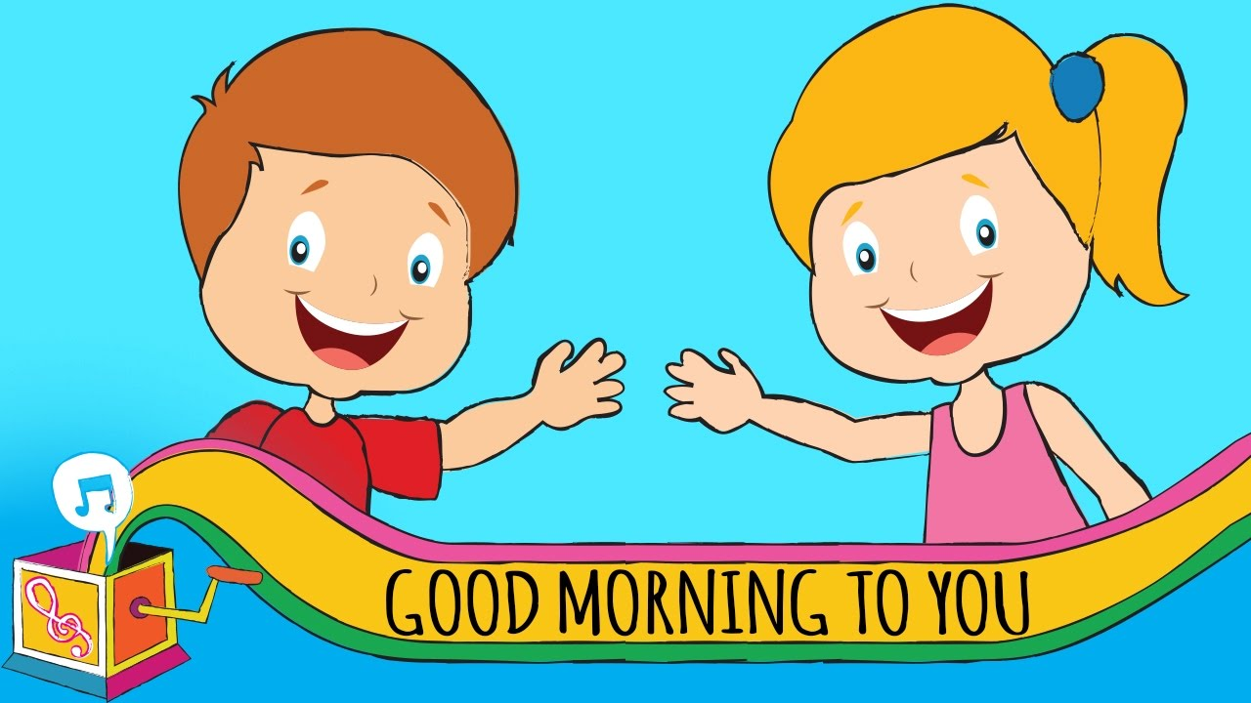

When I get to school in the morning I will say, “Good Morning!” People will feel happy when I say this to them.

People will say good morning to me too! After that I can ask them, “How are you?”

they might ask me how I am. I can say “I am fine, Thank you!”

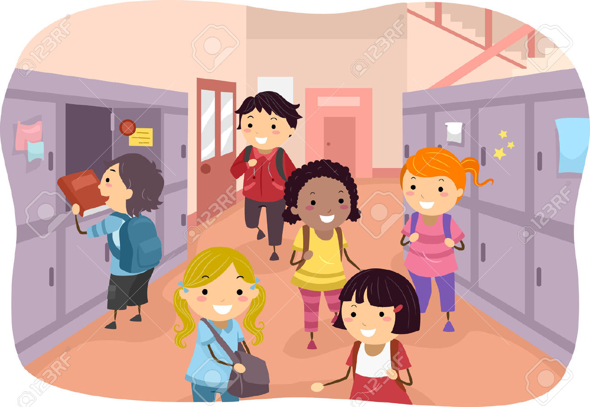

During the day, I will see people that I know in the hallway. I can smile and say, “hi”. This will make them feel good!

See you tomorrow!

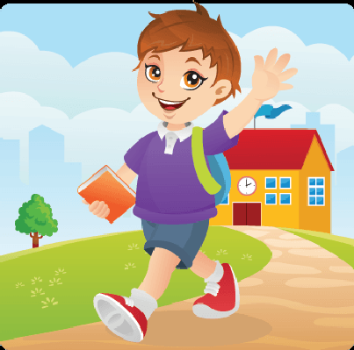

At the end of the day it is time to say goodbye to my friends and teachers. When I see them I can say, “goodbye” or “see you tomorrow”.

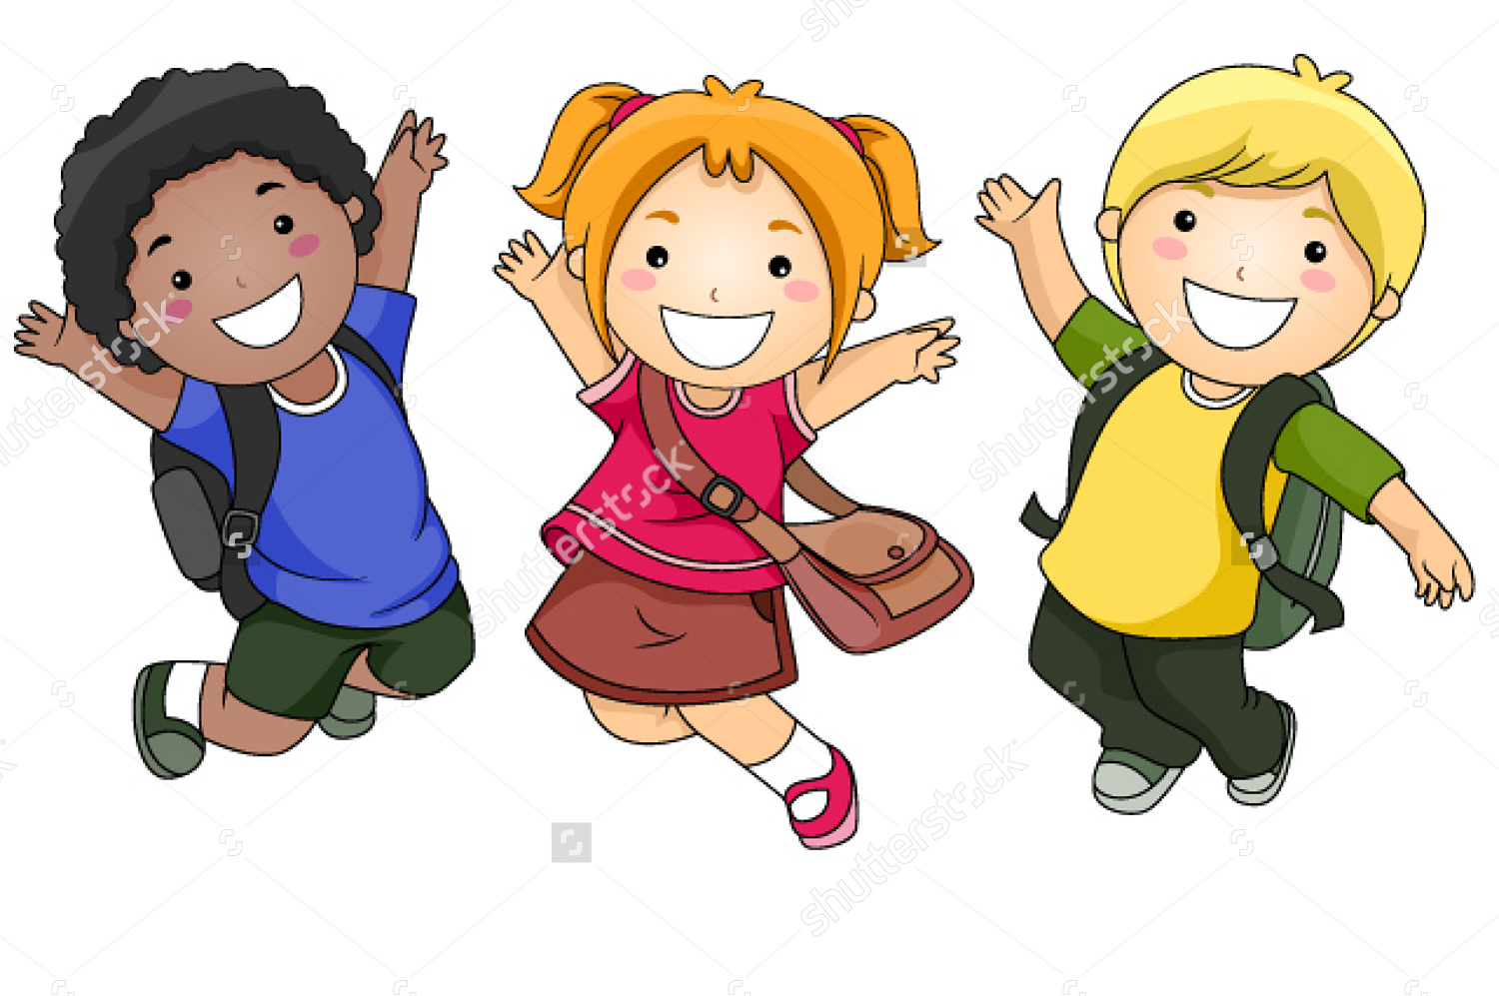

When I greet people by saying hello or goodbye it makes them feel happy. People like to feel happy.

