Reading A-Z: http://www.readinga-z.com/  Username: ginastefanini  Password: maxmouse | 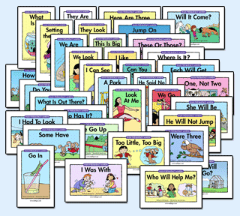 | Leveled Reading Books to print and use this summer. Additional materials provided. Great for all grades.
Into the Book  http://reading.ecb.org/ | 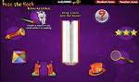 | Supports student comprehension skills, teacher information, and additional resources. Grades 2-6.
Raz-Kids  http://www.raz-kids.com/ | 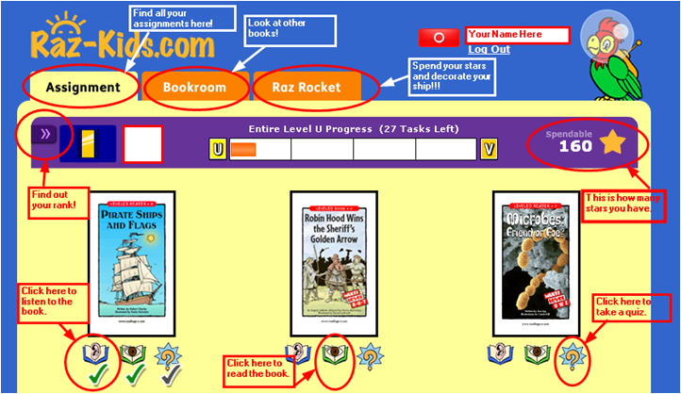 | Listen to books for modeled fluency. Read books with pronunciation and vocabulary support. All Grades.
Starfall  http://www.starfall.com/  http://www.literacycenter.net/lessonview_en.php  http://www.rif.org/kids/readingplanet/gamestation | 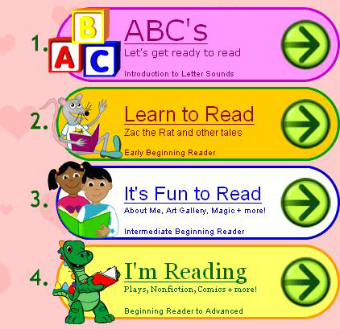 | Starfall is an educational program to read with phonics. Grades K-2.  http://www.literacycenter.net/lessonview_en.php#
Literactive  http://literactive.com/Home/index.asp | 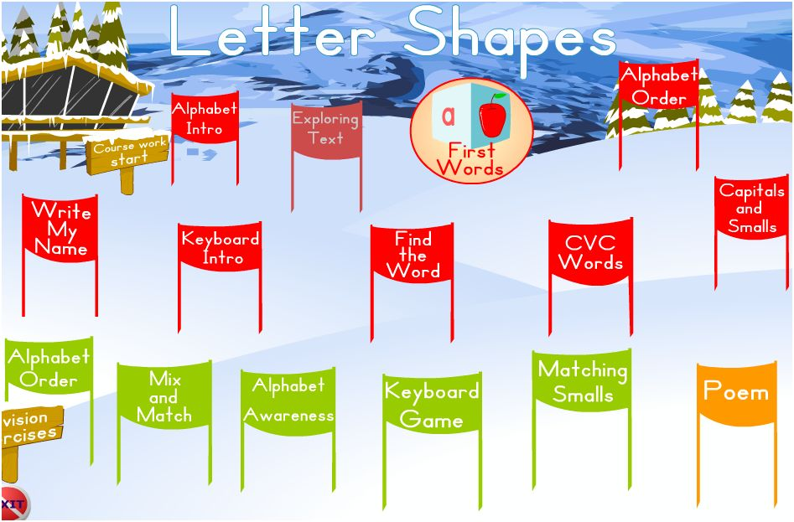 | Literactive has leveled guided readers, comprehensive phonic activities and supplemental reading material. Grades K-2.  http://www.ziggityzoom.com/stories.php
Character Scrapbook  http://teacher.scholastic.com/activities/scrapbook/ | 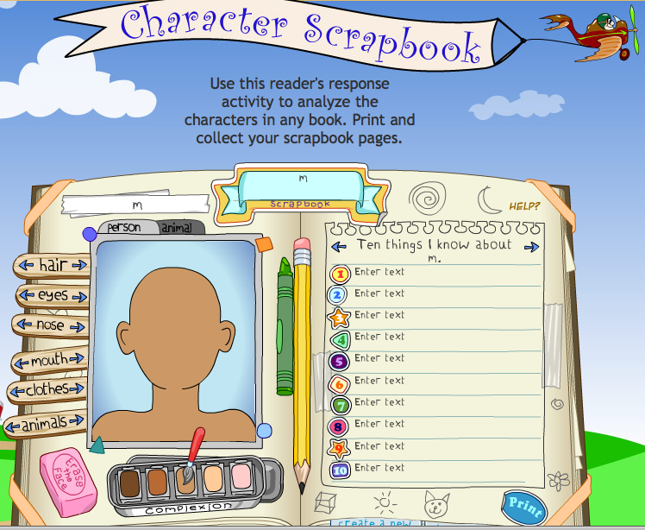 | Use this reader's response activity to analyze the characters in any book. Print and collect your scrapbook pages. All Grades.
Brookline Public Library Digital Library Collection will support background knowledge and vocabulary development | 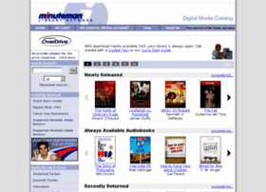 | http://digital.minlib.net/717259F3-9B38-4FDF-B954-17BBD1EEC13A/10/531/en/Default.htm All Grades.  http://www.mln.lib.ma.us/
Digital Texts http://www.storycove.com/classroom/index.cfm?md=Login&sd=Loginform | 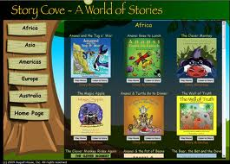 | The Story Cove enables children to explore these stories in a variety of ways while learning about the world. All Grades.
Web-Based Key Board Practice |  | http://www.bigbrownbear.co.uk/keyboard/index.htm  http://www.typing-lessons.org/  http://gwydir.demon.co.uk/jo/typing/index.htm  http://www.bbc.co.uk/schools/typing/  http://www.sense-lang.org/typing/ Grades 3-5.

Other fun writing sites:
- http://www.littlebirdtales.com/ (Little Bird Tales) Interactive writing tool.
- http://storybird.com (Storybird) Interactive writing tool.
- http://www.kerpoof.com/ (interactive writing tool).
- http://www.readwritethink.org/materials/doodle/index.html
- http://www.lightningbug.com.au/ (interactive writing).
- http://www.scholastic.com/underlandchronicles/creaturecreator.htm (creature creator).
- http://www.scholastic.com/dogslife/createtale.htm (Create a tale.)
- http://www.scholastic.com/esperanza/storybuilder.htm (Create a story.)
- http://digitaltoolsforteachers.blogspot.com/2010/04/collection-of-online-story-makers.html (Collection of great story builders.)
- http://www.scholastic.com/inkheart/editorial/index.htm
- http://www.scholastic.com/charlottesweb/comic/index.htm
- http://buildyourwildself.com/
- http://www.storylineonline.net/
- http://www.artisancam.org.uk/flashapps/picturebookmaker/picturebookmaker.php?PHPSESSID=9225166a1ad1eced34b763379f64cdc9
- http://www.pinkydinkydoo.com/storybox.html
- http://play.storybricks.com/play.php
- http://www.storyjumper.com/
- http://zooburst.com/
- http://www.readwritethink.org/files/resources/interactives/comic/index.html
- http://oneword.com/
- http://www.wordle.net/
- http://www.clpgh.org/kids/storymaker/embed.cfm
- http://www.inanimatealice.com/
- http://myths.e2bn.org/index.php (Myths and Legends)
- http://museumbox.e2bn.org/
- http://www.seussville.com/
- http://city.lego.com/en-us/comicbuilder/intro.aspx
- http://www.carnegielibrary.org/kids/storymaker/
- http://www.wix.com/ictmagic/fairytalenews
- http://www.bbc.co.uk/schools/starship/english/storyplant.shtml
- http://www.learner.org/interactives/index.html
- http://www.nga.gov/kids/zone/seasaws.htm
- http://www.rif.org/kids/readingplanet/gamestation
- http://www.culturestreet.org.uk/activities/picturebookmaker/ (bookmaker)
- http://paperrater.com/ (grammar, spelling checker)

Math Sites:
- http://www.glencoe.com/sites/common_assets/mathematics/ebook_assets/vmf/VMF-Interface.html (Interactive manipulative exploration website)
- http://www.harcourtschool.com/thinkmath/index.html (thinkmath website)
- http://www.arcademicskillbuilders.com/ (math game website)
- http://www.aplusmath.com/ (math game website)
- http://www.sheppardsoftware.com/math.htm
- http://www.bbc.co.uk/schools/bitesize/
- http://www.bbc.co.uk/bitesize/ks2/maths/
- http://www.bbc.co.uk/cbeebies/numberjacks/games/
- http://www.crickweb.co.uk/
- http://www.shodor.org/interactivate/tools/
- http://nlvm.usu.edu/
- http://www.harcourtschool.com/activity/adding_bricks_k/
- http://mathforum.org/students/elem/
- http://www.aplusmath.com/
- http://peepandthebigwideworld.com/
- http://www.ftc.gov/bcp/edu/microsites/youarehere/
- http://illuminations.nctm.org/ Explore our library of 108 online activities that help to make math come alive.
- http://www.mathalicious.com/ Mathalicious isn’t just about learning math. It’s also about using math to understand how the world works.
- https://www.xtramath.org/ Math Fact Practice Tool.
- http://www.bigbrainz.com/Articles/Multiplication-Games.html Timez Attack
- http://studyjams.scholastic.com/studyjams/
- https://www.dimensionu.com/home/landing_flash.aspx
- http://labyrinth.thinkport.org/www/
- http://www.mathgametime.com/
- http://www.wordgametime.com/
- http://funschool.kaboose.com/
- http://www.bbc.co.uk/schools/gcsebitesize/
- http://www.howtosmile.org/
- http://mathvids.com/level/show/3-middle-school-math (junior high math)
- http://scratch.mit.edu/
- http://www.turtlediary.com/ (younger children)
- http://studyjams.scholastic.com/studyjams/jams/math/index.htm
- http://www.ixl.com/
- http://www.bigbrainz.com/
- http://www.funbrain.com/math/
- http://singaporemathsource.com/resources/online-programs/
- http://saxonpublishers.hmhco.com/en/onlineactivitiesk-3s.htm
- https://www.xtramath.org/
- http://www.ipl.org/IPLBrowse/GetSubject?vid=12&cid=3&tid=4277&parent=4278
- http://www.bgfl.org/bgfl/custom/resources_ftp/client_ftp/ks1/maths/dice/
- http://www.time-for-time.com/swf/myclox.swf (clock)
- http://nces.ed.gov/nceskids/createagraph/default.aspx (graphing)
- http://www.ipl.org/IPLBrowse/GetSubject?vid=12&cid=3&tid=4277&parent=4278 (list of websites)
- http://www.khanacademy.org/ (online video tutorial)

General Interactive Sites:
- http://www.uen.org/3-6interactives/
- http://www.gameclassroom.com/
- http://www.scholastic.com/browse/learn.jsp?grades
- http://www.bbc.co.uk/cbeebies/games/#/lb/somethingspecial/paintinggame
- http://www.brainpopjr.com/
- http://pbskids.org/
- http://pbskids.org/go/index.html
- http://www.pbskidsplay.org/learnmore
- http://clayyourself.com/ (sculpting with clay)
- http://www.wumpasworld.com/flash.html?langue=e
- http://pbskids.org/lab
- http://www.fuelthebrain.com/
- http://ictmagic.wikispaces.com/
- http://www.thinkfinity.org/student-interactives
- http://www.bbc.co.uk/schools/websites/4_11/index.shtml
- http://www.toonuniversity.com/default.asp?f=t
- http://illuminations.nctm.org/
- http://www.kidsites.com/
- http://www.pbs.org/teachers/
- http://www.arcademicskillbuilders.com/
- http://www.funbrain.com/
- http://www.whyville.net/smmk/nice
- http://illuminations.nctm.org/
- http://www.funbrain.com/
- http://gamestarmechanic.com/ (role playing game where you learn how to make games)
- http://scratch.mit.edu/ (online programming tool)
- http://www.gameclassroom.com/
- http://powermylearning.com/
- www.enterasys.com
- http://www.eduweb.com/
- http://www.gameclassroom.com/
- http://www.arcademicskillbuilders.com/
- http://gamestarmechanic.com/
- http://www.howtosmile.org/
- http://www.turtlediary.com/
- http://www.cookie.com/
- http://learningworksforkids.com/
- http://www.abcya.com/
- http://www.pbskidsplay.org/ ($80 yearly)
- http://www.gridclub.com/ (subscription)
- http://www.freshbrain.org/ (teens)
- http://www.uen.org/k-2interactives/
- http://www.uen.org/3-6interactives/
- http://nces.ed.gov/nceskids/index.asp
- http://www.drawzit.com/ (drawing tool)
- http://www.culturestreet.org.uk/activities/stopframeanimator/ (online animator tool)
- http://www.culturestreet.org.uk/activities/ (interactive art tools – online)
- http://soundation.com/studio (like garageband but free)
- http://4.bp.blogspot.com/-lZnKtfe6p2s/T8ohPzvnzDI/AAAAAAAAGWw/L94PIwY9ZXc/s1600/blooms+taxonomy+for+ipad.png (ipad-Blooms Taxonomy)
- http://interactivesites.weebly.com/

Social Studies
- http://www.plimoth.org/ (Plimoth Plantation, field trip and multimedia content of American History)
- http://www.americaslibrary.gov/ (American History through American Stories)
- http://www.pbs.org/ktca/liberty/ (American Revolution)
- http://www.washingtonsworld.org/ (American History, G. Washington)
- http://www.eduweb.com/portfolio/jeffwest/index.html (American History)
- http://www.eduweb.com/portfolio/history.php (Interactive History Sites)
- http://www.eduweb.com/portfolio/peopleculture.php (People and Culture Interacitves)
- http://www.uen.org/3-6interactives/social_studies.shtml (Interactive History Web Activities)
- http://pbskids.org/krattscreatures/login.shtml (Geography and Living Things)
- http://myhomelearning.com/directory/social-studies
- http://www.timeforkids.com/ (Time for Kids – Current Events)
- http://show.mappingworlds.com/world/ (Maps)
- http://www.cobblestoneonline.net/ (User Name: brookline Password: brookline)
- http://worldbookonline.com/wb/Login?ed=wb
- http://kids.usa.gov/ (US government)
- http://www.countryreports.org/index.htm brookline-brookline
- http://playinghistory.org/
- http://www.eduweb.com/ (virtual experiences)
- http://www.geo-cube.eu/ (geography)
- http://museumbox.e2bn.org/ (virtual history ‘shoebox’)
- http://www.peacecorps.gov/kids/ (solve dilemmas for a village)
- http://www.timeforkids.com/
- http://learning.blogs.nytimes.com/

Science
- http://www.eduweb.com/portfolio/earthspacesci.php (Earth and Space Science)
- http://www.howtosmile.org/
- http://www.uen.org/3-6interactives/science.shtml (Interactive Science Web Activities)
- http://kids.nationalgeographic.com/kids/ (Living Things)
- http://www.earthfromspace.si.edu/ (Universe)
- http://spaceplace.nasa.gov/ (Universe)
- http://www.pbs.org/wnet/nature/category/interactives-extras/interactives-games/ (Living Things, Earth)
- http://myhomelearning.com/directory/science
- http://www.nps.gov/webrangers/ (Junior Park Ranger Program)
- http://www.scholastic.com/magicschoolbus/index.htm (Magic School Bus)
- http://studyjams.scholastic.com/studyjams/index.htm
- http://www.poissonrouge.com/
- http://www.sciencecomics.uwe.ac.uk/index.php
- http://www.physicsgames.net/game/Huje_Tower.html
- http://www.sciencecompanion.com/
- http://www.wordworld.com/ebook1/index.html
- http://streaming.discoveryeducation.com/index.cfm
- http://kids.discovery.com/
- http://catalog.brookline.k12.ma.us/
- http://streaming.discoveryeducation.com/
- http://www.wolfquest.org/ 3D wildlife simulation game that lets player s learn about wolf ecology by living the life of a wild wolf in Yellowstone National Park.
- http://peepandthebigwideworld.com/
- http://kidshealth.org/kid/
- http://www.sciencekids.co.nz/ (New Zealand – science content resources)
- http://www.professorgarfield.com/pgf_home.html
- http://www.nasa.gov/audience/forkids/kidsclub/flash/index.html
- http://www.howtosmile.org/ How to Smile is an online community of educators that have vetted over 3,000 engaging hands-on, interactive STEM activities.
- http://www.arkive.org/ ARKive gathers together films, photographs, and audio recordings of the world’s species to establish a comprehensive multimedia digital collection of profiles of species either rare or threatened with extinction.
- http://www.sciencebob.com/index.php
- http://www.exploratorium.edu/ The Exploratorium isn’t just a museum; it’s an ongoing exploration of science, art, and human perception—a vast collection of online interactives, web features, activities, programs, and events that feed your curiosity.
- http://studyjams.scholastic.com/studyjams/jams/science/index.htm
- http://apod.nasa.gov/apod/ap120312.html (how big/small is it?)
- http://sciencenetlinks.com/tools/

ebooks
- http://www.barnesandnoble.com/storytime/index.asp
- http://www.storylineonline.net/
- http://www.wegivebooks.org/
- http://learning.blogs.nytimes.com/ (NYTimes blog gives young people fluff-free news)

Book Connections
- http://www.seussville.com/
- http://juniebjones.com/
- http://pbskids.org/martha/
- http://www.magictreehouse.com/#
- http://www.randomhouse.com/kids/berenstainbears/
- http://www.janbrett.com/index.html
- http://www.bookadventure.com/Home.aspx
- http://pbskids.org/arthur/
- http://www.kidsreads.com/
- http://youarewhatyouread.scholastic.com/kids/
- http://www.googlelittrips.org/ (upper grades)

Typing Programs
- http://www.bbc.co.uk/schools/typing/

Teacher Resources
- http://www.wbrschools.net/technology.htm (Amazing collection for Educators)
- http://mathforum.org/mathtools/sitemap2/k/
- http://www.curriki.org/
- http://ictmagic.wikispaces.com/
- http://www.online-stopwatch.com/ (stop watch)
- http://www.worksheetworks.com/

Search Engine
- http://www.ipl.org/div/kidspace/
- http://www.diigo.com/index
- http://www.kidsknowit.com/
- http://www.ipl.org/
- http://factcheck.org/ (search for fact checking information)

Study Tools
- http://www.studyblue.com/teachers/ (study tool)
- http://www.google.com/options/
- http://soundcloud.com/ (send voicemail for homework)

Graphic Organizers
- http://nces.ed.gov/nceskids/createagraph/default.aspx
- http://www.teachervision.fen.com/graphic-organizers/printable/6293.html?detoured=1
- http://quizlet.com/
- https://bubbl.us/ (brainstorming tool) http://nces.ed.gov/nceskids/createagraph/default.aspx?ID=cf19a325bce1495b8284d99820b4e9f1 (create a graph)
- http://www.worksheetplace.com/

Website Lists
- http://www.ala.org/aasl/guidelinesandstandards/bestlist/bestwebsitestop25
- http://www.ala.org/aasl/guidelinesandstandards/bestlist/2011bestwebsites
- http://gws.ala.org/
- http://www.commonsensemedia.org/website-lists
- http://www.mrnussbaum.com/
- http://www.diigo.com/cloud/ginastefanini
- http://www.howtosmile.org/
- http://mass.pbslearningmedia.org/
- http://www.ipl.org/

Content Videos
- http://www.schooltube.com/ (general collection)
- http://www.watchknowlearn.org/default.aspx
- http://www.khanacademy.org/ (math and science videos)
- http://creativecommons.org/ (small, selective topics on current social issues)
- http://www.teachertube.com/ (general Collection)
- http://www.refseek.com/directory/educational_videos.html
- http://www.hippocampus.org/
- http://www.meetmeatthecorner.org/ Kids' YouTube alternative offers insight into other lives.
- http://mediacore.com/why-mediacore/education (video and tools)
- http://www.commonsensemedia.org/website-lists/best-video-sites (list)
- http://gettingsmart.com/blog/2012/07/35-sources-curated-educational-videos/ (list)
- http://edudemic.com/2012/08/best-video-sites-for-teachers/ (list)
- http://community.eflclassroom.com/video
- http://www.libraryvideo.com/default.asp?mscssid=undefined
- http://www.studysync.com/ 175 a year for 90 students
- http://k12videos.mit.edu/

